Testing Documentation

Normal Case:

The game begins by loading the background bitmap and small title at the top of the screen, with the player sprite located at the bottom of the screen in the center. As time passes, 2 enemy types will randomly appear on the screen. The user can move the player sprite with the arrow keys and fire projectiles with the spacebar. As the player sprite moves left or right, the sprite will change it's animation to reflect this motion, along with the standard sprite animation of it's rocket engines firing. When bullets are fired, they travel vertically up the screen until they strike an enemy sprite, or move past the top of the screen.

Enemies appear as two types of sprites; a UFO and alien spaceship. The UFO appears every 1.5 seconds after it is destroyed or leaves the bottom of the screen. It's movement is diagonal across the screen, and will reverse direction whenever it hits the sides of the screen. The alien spaceship only travels in straight lines. Horizontally it can move left or right, and vertically it only travels downward. It appears every second after being destroyed or exiting the screen. Enemy sprites are considered destroyed and will disappear after colliding with user fired projectiles or the user sprite itself.

As soon as the game starts up, the music will play in a continuous loop. There is only one track that plays. As the player fires projectiles, a laser sound effect will play. When the UFO sprite appears on the screen, there is an accompanying sound effect that plays the entire time it is visible. The alien spaceship sprite also has a flyby sound effect which plays when it appears. Lastly, when an enemy is destroyed by a projectile or player contact, and explosion sound effect will play.

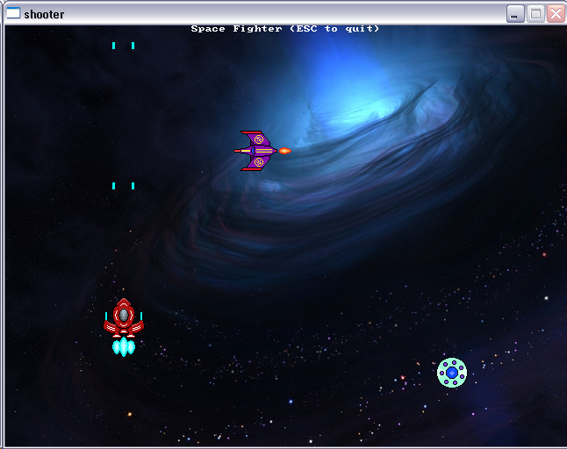A screenshot from the game

Bad data case: User holds down the keys, stops moving with the arrow keys

As previously mentioned, the user controls their sprite with the arrow keys, and fires with the spacebar. Due to the repeat rate of the keyboard, this can result in many inputs being generated very quickly, especially for firing the weapon. For the player movement, this isn't really an issue, but for the weapon this is handled by setting a time interval in which the player cannot fire. The time is constantly tracked, after 200 milliseconds have passed since the previous shot, the player is allowed to shoot again. This results in a more desirable firing effect.

When the player changes direction with the arrow keys, the movement is easily updated, and the sprite will change it's animation for horizontal movement left or right. However, when the player lets go of the arrow keys, the sprite stops moving immediately, at the end of every cycle, the player sprite velocity is reset to 0 to stop the sprite's motion. The animation is also reset to the default.

Bad data case: Screen boundaries

As the player moves about the game screen, they can try to keep moving past the edges by continually pressing the arrow keys. The program will check the position of the player at every game loop to ensure that they have not exceeded the bounds. If so, the sprite is reset to appear within the bounds. The player will not notice the reset due to the buffering effect of the game.

Enemy sprites have the capability of exceeding the screen bounds as well. They are given more leeway to move off the screen than the player sprite, but once they are completely off the screen, they are no longer considered active and will not be processed by most functions. This will also trigger the timer that will make them reappear as a randomly generated enemy.

Bad data case: Lots of sound and music playing at once

The problem of having so many sounds as well as background music is handled by having each sound have it's own voice in the Allegro sound system. This allows finer control of playback. This is especially necessary for the player firing the weapon, because it occurs so frequently and rapidly. Each time the weapon fires, the sound will stop playing (if currently playing), reset it's position to the beginning of the sample, and play again. The same is true for the enemy explosion sound. As enemies may die in rapid succession, the explosion sound is stopped and restarted in a similar manner.

Bad data case: Overlapping sprites

As the user plays the game, they can freely move around the screen. This allows them to come into contact with the enemy sprites that randomly move around the screen. Additionally, this randomness will occasionally cause enemy sprites to overlap as well. Finally, the player can fire projectiles that travel vertically up the screen that may also overlap with sprites.

In the first case, when the player sprite comes into contact with an enemy sprite, the program detects the collision by checking for it with every loop of the main game loop. When this collision is detected, the enemy sprite will be destroyed and disappear from the screen, triggering the timer that will eventually create a new enemy.

In the second case, the movement of enemies will cause overlap. This is not handled by the program. Enemies are allowed to freely overlap one another as handling collisions is not really necessary in this case. As enemy collisions do not really have an effect on the player.

Finally, collisions with projectiles are consistently checked for by the program. As each projectile appears, it moves in a vertical direction faster than the player sprite can move, and therefore will not end up overlapping. If this were not the case, collisions would probably be disregarded as the player would not want to be destroyed by their own projectiles. What the program does handle, is enemy-projectile collisions. This is checked with each iteration of the game loop for every visible enemy and projectile. Collisions will cause both the enemy sprite and projectile to disappear from the screen, and remove them from most of the game processing.

Bad data case: File loading errors

If the program fails to load any bitmaps or sound files, the game will display a message and possibly exit the game.

